1) Write the output for each piece of code. If the code gives an error, write “ERROR”.
Show your work and the changes in memory. (5pts each subquestion a-c)
 | Code
a | int [] numsA = new int[4];  int [] numsB = {7,12,9,10};  for(int i=0; i<numsA.length; i++){  if(i % 2 == 0){  numsA[i] = numsB[i];  }  else{  numsA[i] = i+3;  }  } |  | Array Content numsA  Array Content numsB
b | char[] arrA={'c','a','d','b','u','r','y'};  char[]arrB={'c','h','o','c','o','l','a','t','e','s'};  char[] arrC={'c','a','n','d','i','e','s'};  arrA[2] = arrB[7];  arrA[6] = arrB[9];  arrC[4] = arrB[5];  arrB = arrA;  //arrA[1] = arrB[5];  arrA[3] = 'f'; |  | Array Content arrA  Array Content arrB  Array Content arrC
c | public static void q1C(char c, int x){  switch(c){  case 'z':  System.out.println("zoo");  int b = x;  while(b > 0){  System.out.println(b+" b");  b--;  }  break;  case 'm':  System.out.println("monkeys");  case 'b':  for(int i=0; i<x; i++){  System.out.println("bananas");  }  break;  default:  System.out.println("chaos");  break;  }  } | Method Call | Output
 |  | q1C(‘z’, 3);
 |  | q1C(‘m’, 2);
 |  | q1C(‘b’, 3);
 |  | q1C(‘a’, 3);

2) The Java class Player is described below. Complete the Player class as per the instructions.
This class has 4 private instance variables: (5pts each subquestion a-h)
- playerName, which is a String representing the name of the Player object
- jerseyNum, which is an int representing the jersey number
- isAllowedToPlay,which is a boolean representing whether the Player can play or not
- positionsPlayed, which is a String [] containing the positions the Player plays

2a) Declare the 4 private instance variables, but do not assign any values to them.

2b) Write the default constructor which assigns the following default values to the variables
Instance Variable | Value
playerName | “Doe Player”
jerseyNum | -1
isAllowedToPlay | true
positionsPlayed | 5

2c) Write an overloaded constructor that takes in 4 arguments and assigns the values to the matching private instance variables playerName, jerseyNum, isAllowedToPlay, positionsPlayed of the Player Object.

2d) Write the getter and setter methods for 2 of the variables: playerName,and jerseyNum.
You can Assume the other getters and setters have been written for you.

2e) Write a method getPositionsAsString()
It should return a single String containing all the values in the positionsPlayed array separated by commas. Be sure there is no trailing comma at the end.
Example contents of String array positionsPlayed:(assuming a player was capable of playing ALL positions well)
Center
Point
Guard
Small Forward
Power
Forward
Shooting Guard
0
4
1
2
3
String would be “Center, Small Forward, Power Forward, Shooting Guard, Point Guard”

2f) Override the toString() method so that it returns a well formatted String consisting of the names and values of all of the Players instance variables. Use the helper method from 2e.
Example Strings for three different players:
“Player: name=Antetokounmpo, jersey num=34, is allowed to play, positions played = small forward, shooting guard, point guard”
“Player: name=Jordan, jersey num=23, is not allowed to play, positions played = small forward, shooting guard, point guard”
“Player: name=Bird, jersey num=33, is not allowed to play, positions played = small forward, power forward”

2g) Override the equals(Object o) method so that it returns true if the values of playerName, jerseyNum, isAllowedToPlay,match for the calling object and the passed in object. Return false otherwise.
Note: don’t worry about the positionsPlayed for this question.

2h) Use your constructor from part (2c) to create 3 separate instances of class Player with the following values:
“Player: name=Antetokounmpo, jersey num=34, is allowed to play, positions played = small forward, shooting guard, point guard”
“Player: name=Jordan, jersey num=23, is not allowed to play, positions played = small forward, shooting guard, point guard”
“Player: name=Bird, jersey num=33, is not allowed to play, positions played = small forward, power forward”

//Write your answer to question 2 here
3) Use the Interface Skills shown below, and the code from question 2 to complete question 3.
public interface Skills {
public void move();
public void shoot();
public void pass(String otherPlayerName);
}

- Create the 2 classes, MostValuablePlayer and BenchedPlayer so that they become a child/subclass of Player and implement the Skills Interface.

- For both classes, create the default constructor so that it calls the super class’s default constructor and assigns the default value shown below for the child class’s boolean hasSkills instance variable.
MostValuablePlayer assign true to the hasSkills variable.
BenchedPlayer assign false to the hasSkills variable.

- Override the move() method using getters when necessary:
MostValuablePlayer print: “So fast! You can’t see me”
BenchedPlayer print: “Oh so slow...lost the ball”

- Override the shoot() method using getters when necessary:
MostValuablePlayer print: “SWISH! “
BenchedPlayer print: “Missed… no skills”

- Override the pass(String otherPlayerName) method using getters when necessary:
MostValuablePlayer print: “I am passing to “+otherPlayerName
BenchedPlayer print: “I tried to pass to ”+otherPlayerName
//Answer question 3 here BenchedPlayer | //Answer question 3 here MostValuablePlayer

//More room to write your answer if needed

4) Remember the Recursive Search algorithm Binary Search. Write a recursive method named binarySearch that will do the following:
- Take in an array of type char, a target of type char, the startIndex, and the endIndex.
- Use recursion to find a match for the target and return the index location of the match.
- Return -1 if no match exists in the array.

5) The Java GUI Project ScoreTracker is started below.
Do the following to complete the GameScoreJPanel. (Don’t worry about the JFrame… it’s code is not here)
  - Fill in everything that is missing from the class to assure the following:
    - The class is a JPanel
    - The class implements the ActionListener interface
- Create new instances of the JButtons so they say “Team A” , “Team B” accordingly.
    - Make the JButtons listen for actions.
    - Add them both to the nested jpScore JPanel
- Create the method updateWinnerLabel() such that it uses scoreA and scoreB to do the following:
    - Compare scoreA to scoreB, and set the jlblWinner text
    - If noone has won yet (score is less than MAX_POINTS) do the following:
      - Set the text to show which team is ahead
      - Set the text to show “Tight game” when the score is tied
    - If one of the teams wins (the score equals MAX_POINTS) do the following:
      - Set the text of the jlblWinner to show the winner, then call resetScores()
- Create the method resetScores so that it will do the following
    - Set the variables scoreA and scoreB values’s to 0
    - Set the text on jlblA and jlblB so they read “A: 0” and “B: 0” using the scores variables
- Create the method actionPerformed below, such that it does the following:
    - Determines which button was clicked
    - Increments the appropriate team’s score
    - Sets the text on jlblA or jlblB to display the updated score
    - Calls updateWinnerLabel() so it can update the jlWinner status accordingly

Below are some screenshots of the game’s progress.. Not all screenshots, just some.
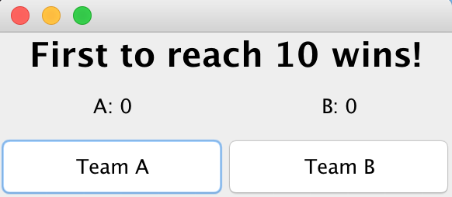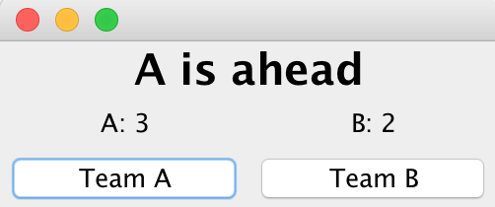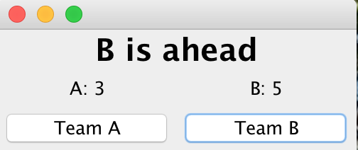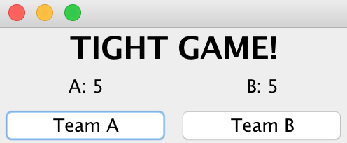
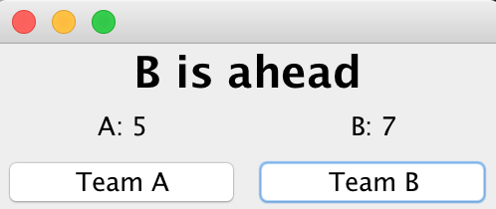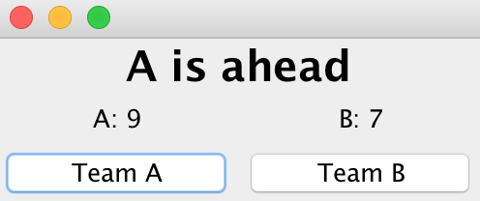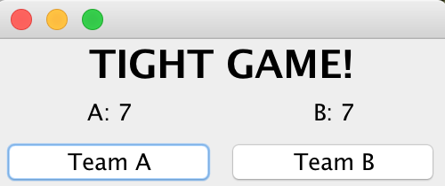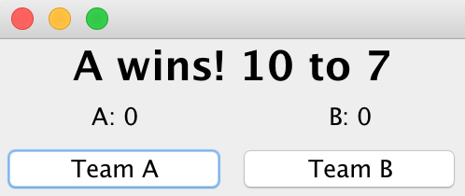

public class GameScoreJPanel_______________________________________________{//5a your code here
private JPanel jpScore;
private JLabel jlblA, jlblB, jlblWinner;
private JButton jbA, jbB;
private int scoreA = 0; private int scoreB = 0;
public static final int MAX_POINTS = 10;

public GameScoreJPanel(){
setLayout(new BorderLayout());
jpScore = new JPanel();
jpScore.setLayout(new GridLayout(2,2));
jlblA = new JLabel("A: "+ scoreA);
jlblB = new JLabel("B: "+ scoreB); //5b Write your code below

jpScore.add(jlblA);
jpScore.add(jlblB);
add(jpScore, BorderLayout.CENTER);
add(jlblWinner, BorderLayout.NORTH);
} //end of GameScoreJPanel Constructor
//5c Write code for the updateWinnerLabel method below

//5d Write code for the resetScores() method below

//5e Fill in the actionPerformed method below
public void actionPerformed(ActionEvent e) {

}

}

